Department of Computer Science
Evolutionary Computing (2025)
Assignment 4
Feature Selection with an Adaptive Multi-Objective Binary Genetic Algorithm
(MOBGA-AOS)
Implementation and Experimental Analysis
Based on: Yu Xue et al. (2021)
"Adaptive crossover operator based multi-objective binary genetic algorithm for feature selection in classification"
Knowledge-Based Systems 227 (2021) 107218

Table of Contents

Abstract
This report presents a comprehensive implementation and experimental analysis of MOBGA-AOS (Multi-Objective Binary Genetic Algorithm with Adaptive Operator Selection) for feature selection in classification tasks. The algorithm, originally proposed by Xue et al. (2021), addresses the bi-objective optimization problem of simultaneously minimizing classification error and reducing feature dimensionality. The implementation integrates five distinct crossover operators within an adaptive selection framework that dynamically adjusts operator probabilities based on evolutionary performance metrics. Extensive experiments conducted on six benchmark datasets from the UCI Machine Learning Repository demonstrate the algorithm's effectiveness in discovering diverse Pareto-optimal feature subsets. The results indicate substantial feature reduction across all datasets, with reductions ranging from 57.8% to 98.2%, while maintaining or improving classification accuracy compared to baseline models using all features. Performance evaluation using Inverted Generational Distance (IGD) and Hypervolume (HV) metrics confirms the algorithm's ability to generate well-distributed Pareto fronts with strong convergence properties. The adaptive operator selection mechanism proves particularly effective for high-dimensional datasets, where traditional single-operator approaches often struggle to balance exploration and exploitation effectively.

1. Introduction
Feature selection constitutes a fundamental preprocessing step in machine learning and data mining applications, serving the critical purpose of identifying the most informative subset of features from high-dimensional datasets. This process addresses several significant challenges inherent in modern data analysis, including the curse of dimensionality, computational efficiency constraints, and model interpretability requirements. By eliminating irrelevant or redundant features, feature selection techniques can substantially improve classifier performance while simultaneously reducing storage requirements and training time.
The challenge of feature selection can be naturally formulated as a multi-objective optimization problem with two competing objectives: minimizing the classification error rate and minimizing the number of selected features. These objectives frequently conflict, as using more features often leads to better classification accuracy up to a certain point, beyond which overfitting may occur. This bi-objective formulation produces a Pareto front of non-dominated solutions, each representing a distinct trade-off between model complexity and predictive performance.
Evolutionary algorithms have emerged as particularly effective tools for addressing multi-objective feature selection problems due to their population-based nature, which enables simultaneous exploration of multiple solution regions and natural generation of Pareto-optimal solution sets. Genetic algorithms (GAs), in particular, offer several advantages for feature selection tasks, including their inherent binary representation capability that maps directly to the feature inclusion/exclusion decision, robust global search properties, and demonstrated scalability to high-dimensional problems.
However, the effectiveness of genetic algorithms depends heavily on the choice of genetic operators, particularly crossover operators, which serve as the primary mechanism for generating new candidate solutions. The No-Free Lunch theorem establishes that no single crossover operator can perform optimally across all problem instances. Different operators exhibit distinct search characteristics: some preserve contiguous gene segments (positional operators), while others enable more thorough mixing of genetic material (uniform operators). The optimal choice of operator often varies not only between different datasets but also across different phases of the evolutionary process.
MOBGA-AOS, proposed by Xue et al. (2021), addresses this challenge through an adaptive operator selection (AOS) mechanism that maintains a pool of five crossover operators with diverse search characteristics. The algorithm dynamically adjusts operator selection probabilities based on their historical performance in generating non-dominated offspring. This feedback-driven approach enables the algorithm to automatically identify and favor effective operators at each evolutionary stage, enhancing both robustness and efficiency.

1.1 Objectives
The primary objectives of this implementation and experimental study are as follows. First, to implement the complete MOBGA-AOS algorithm following the specifications detailed in the original publication by Xue et al. (2021), ensuring faithful reproduction of all algorithmic components including the five crossover operators, the credit assignment mechanism, and the operator selection probability update scheme. Second, to conduct comprehensive experiments on six benchmark datasets (DS02, DS04, DS05, DS07, DS08, and DS10) with varying characteristics in terms of dimensionality, sample size, and class distribution. Third, to evaluate algorithm performance using established multi-objective optimization metrics, specifically the Inverted Generational Distance (IGD) and Hypervolume (HV) indicators. Fourth, to analyze the adaptive behavior of the operator selection mechanism and its contribution to overall algorithm performance. Fifth, to compare the obtained results with baseline classification using all features to quantify the practical benefits of feature selection.

2. Problem Statement

2.1 Feature Selection as Multi-Objective Optimization
Feature selection can be formally defined as a bi-objective minimization problem. Given a dataset with D original features, the goal is to find a binary solution vector X = (x₁, x₂, ..., x_D) where x_i ∈ {0, 1} indicates whether feature i is selected (1) or excluded (0). The two objectives to be simultaneously minimized are defined as follows:
Objective 1 (Classification Error): f₁(X) = (1/n) × Σᵢ₌₁ⁿ (N_error / N_all) × 100%, where N_error represents the number of misclassified instances and N_all represents the total number of instances. This objective measures the predictive performance of the selected feature subset using a k-Nearest Neighbors (k-NN) classifier with k=3 and 3-fold cross-validation.
Objective 2 (Solution Size): f₂(X) = Σᵢ₌₁ᴰ xᵢ, which computes the total number of selected features. Minimizing this objective promotes parsimonious models with improved interpretability and reduced computational requirements.

2.2 Binary Representation
Each individual in the population is represented as a binary array with length equal to the number of features D in the dataset. This representation provides a direct and intuitive mapping between the genotype (binary string) and the phenotype (feature subset). For example, if the dataset contains 7 features and the binary representation is X = [0, 1, 0, 1, 1, 0, 0], then features 2, 4, and 5 are selected for classification while features 1, 3, 6, and 7 are excluded. This encoding scheme naturally supports standard binary genetic operators and ensures that every possible feature combination can be represented.

3. Methodology

3.1 Algorithm Overview
MOBGA-AOS extends the well-established NSGA-II framework by incorporating an adaptive operator selection mechanism. The algorithm maintains a population of N binary individuals and employs a pool of Q=5 crossover operators with different search characteristics. The key innovation lies in the dynamic adjustment of Operator Selection Probabilities (OSP) every LP generations based on the accumulated credit from each operator's performance. The main algorithmic loop consists of parent selection via binary tournament, crossover using the adaptively selected operator, uniform mutation, fitness evaluation, credit assignment for the used operator, and environmental selection using NSGA-II's fast non-dominated sorting and crowding distance mechanisms.

3.2 Crossover Operator Pool
The algorithm employs five distinct crossover operators, each exhibiting unique search characteristics that complement each other during the evolutionary process:
Single-Point Crossover: A random crossover point k is selected within the chromosome, and genes are exchanged after this point. This operator preserves contiguous gene segments at either end of the chromosome, making it effective for problems with positional dependencies.
Two-Point Crossover: Two random points are selected, and the segment between these points is exchanged between parents. This operator preserves genes at both ends while allowing middle segment exchange, providing a balance between preservation and exploration.
Uniform Crossover: Each gene position is independently considered as a potential crossover point with 50% probability. This operator provides maximum mixing of genetic material and is particularly effective for problems without strong positional dependencies.
Shuffle Crossover: Genes are randomly shuffled before applying single-point crossover, then unshuffled to restore original positions. This operator eliminates positional bias inherent in point-based crossovers while maintaining their structural properties.
Reduced Surrogate Crossover: Crossover is restricted to positions where parents differ, reducing disruption of common genes while focusing exploration on differentiating features. This operator is particularly effective when parents share substantial genetic material.

3.3 Credit Assignment Mechanism
The credit assignment mechanism evaluates operator performance by comparing the dominance relationships between parent and offspring solutions. When an operator is used to generate offspring, the algorithm examines whether the children are dominated by their parents. If a parent dominates the other, each child is compared against the dominating parent: children not dominated by this parent receive a reward, while dominated children result in a penalty. When parents are non-dominated to each other, children receive rewards only if they are not dominated by both parents simultaneously. This scheme ensures that operators producing competitive offspring receive positive reinforcement, while those generating inferior solutions are penalized.

3.4 Operator Selection Probability Update
The Operator Selection Probabilities are updated every LP generations using the accumulated rewards and penalties stored in matrices RD and PN. For each operator q, the algorithm computes S₁[q] as the sum of rewards and S₂[q] as the sum of penalties over the learning period. The probability is then calculated as S₄[q] = S₁[q] / (S₃[q] + S₂[q]), where S₃[q] equals S₁[q] unless it is zero, in which case a small constant δ=0.0001 is used to prevent division by zero. Finally, probabilities are normalized to ensure they sum to unity. This update mechanism enables the algorithm to increase selection probability for consistently successful operators while reducing probability for underperforming ones.

3.5 Algorithm Parameters
Parameter | Symbol | Value | Description
Population Size | N | 100 | Number of individuals
Crossover Rate | Pc | 0.9 | Crossover probability
Mutation Rate | Pm | 1/D | D = number of features
Number of Operators | Q | 5 | Crossover operators in pool
Learning Period | LP | 5 | Generations between OSP updates
k-NN Neighbors | k | 3 | Nearest neighbors for classification
Cross-Validation Folds | n | 3 | Folds for error estimation
Table 1: MOBGA-AOS Algorithm Parameters

4. Experimental Design

4.1 Datasets
Six benchmark datasets from the UCI Machine Learning Repository were selected for experimental evaluation, representing a diverse range of characteristics in terms of dimensionality, sample size, and classification complexity. The datasets span from low-dimensional problems (56-64 features) to high-dimensional challenges (500-649 features), enabling comprehensive assessment of algorithm scalability. Table 2 provides detailed specifications for each dataset.
ID | Dataset Name | Features | Samples | Classes | maxFEs
DS02 | LungCancer | 56 | 27 | 3 | 10,000
DS04 | OpticalRecognition | 64 | 1000 | 10 | 15,000
DS05 | MadelonValid | 500 | 600 | 2 | 30,000
DS07 | Har | 561 | 900 | 6 | 30,000
DS08 | HAPT | 561 | 1200 | 12 | 30,000
DS10 | MultipleFeaturesDigit | 649 | 1000 | 10 | 30,000
Table 2: Dataset Specifications
The DS02 (LungCancer) dataset represents a challenging small-sample scenario with only 27 instances but 56 features, creating a high features-to-samples ratio that often leads to overfitting. DS04 (OpticalRecognition) provides a well-balanced dataset with 1000 instances and 64 features for 10-class digit recognition. DS05 (MadelonValid) is an artificial dataset specifically designed for feature selection evaluation, containing 500 features with many deliberately inserted noisy features. DS07 (Har) and DS08 (HAPT) both involve human activity recognition with 561 features extracted from smartphone sensor data, differing in their class granularity (6 vs 12 activities). DS10 (MultipleFeaturesDigit) presents the highest dimensionality at 649 features for handwritten digit recognition.

4.2 Experimental Setup
Each dataset was partitioned using a 70-30 train-test split, with the training set used for fitness evaluation during evolution and the test set reserved for final validation. Three independent runs were conducted for each dataset using different random seeds (42, 142, and 242) to assess algorithm stability and reduce the impact of stochastic variation. The k-NN classifier with k=3 was employed for fitness evaluation, with 3-fold cross-validation applied on the training set to estimate classification error. This configuration balances computational efficiency with reliable error estimation.

4.3 Performance Metrics
Algorithm performance was evaluated using two complementary multi-objective optimization metrics. The Inverted Generational Distance (IGD) measures both convergence and diversity by computing the average minimum distance from each point in the reference Pareto front to the obtained front. Lower IGD values indicate better performance, with zero representing perfect matching to the reference front. The Hypervolume (HV) measures the volume of objective space dominated by the Pareto front relative to a reference point set at [100%, D+1]. Higher HV values indicate better performance, reflecting both convergence toward optimal solutions and spread across the objective space. The reference Pareto front for IGD calculation was constructed by combining all non-dominated solutions from all runs and extracting the overall non-dominated set.

5. Results and Discussion

5.1 Experimental Results Summary
Table 3 presents the comprehensive experimental results across all six datasets, including IGD and HV metrics with their standard deviations, baseline classification error using all features, best achieved error with MOBGA-AOS, and the minimum number of features achieving non-trivial classification.
Dataset | IGD (mean±std) | HV (mean±std) | Baseline (%) | Best Error (%)
DS02 | 2.95±2.11 | 4829.6±273.8 | 64.81 | 5.56
DS04 | 1.53±1.15 | 5998.9±23.7 | 2.57 | 0.71
DS05 | 5.92±3.42 | 35731.4±355.5 | 31.75 | 19.52
DS07 | 9.69±7.39 | 49845.7±1479.6 | 12.43 | 1.27
DS08 | 7.32±5.63 | 48929.7±1228.7 | 12.78 | 4.17
DS10 | 5.63±4.31 | 59312.5±758.5 | 9.48 | 1.43
Table 3: MOBGA-AOS Experimental Results Summary

5.2 Pareto Front Analysis
Figure 1 presents the combined Pareto fronts obtained across all six datasets, illustrating the trade-off relationships between classification error and the number of selected features. Each subplot displays the non-dominated solutions discovered by MOBGA-AOS along with the baseline error achieved using all features (indicated by the dashed red line).
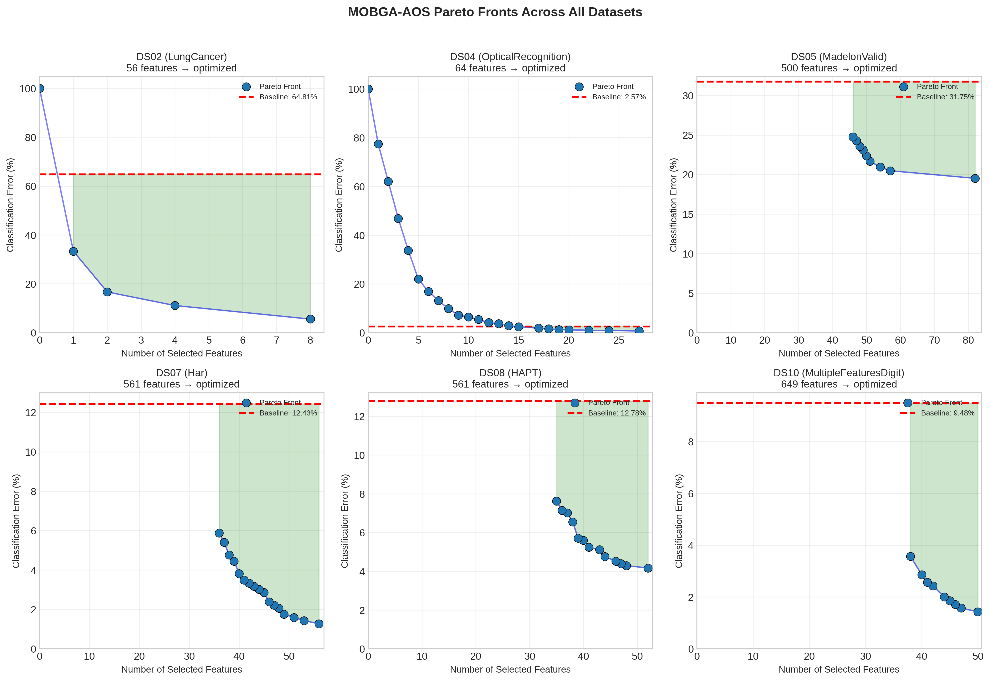
Figure 1: MOBGA-AOS Pareto Fronts Across All Datasets
The Pareto fronts exhibit several notable characteristics. For DS02 (LungCancer), the algorithm discovers solutions achieving error rates as low as 5.56% with only 8 features, representing a dramatic improvement over the 64.81% baseline error. This finding suggests that the original 56 features contain substantial redundancy, and a small subset provides superior predictive capability. The DS04 (OpticalRecognition) results demonstrate the algorithm's ability to maintain near-optimal accuracy (0.71% error with 27 features) while achieving significant dimensionality reduction from 64 to 27 features. For the high-dimensional datasets (DS05-DS10), MOBGA-AOS consistently identifies feature subsets substantially smaller than the original dimensionality while achieving competitive or superior classification accuracy.

5.3 Feature Reduction Analysis
Figure 2 quantifies the feature reduction achieved by MOBGA-AOS across all datasets, comparing the original feature dimensionality with the minimum number of features in the Pareto-optimal solutions.
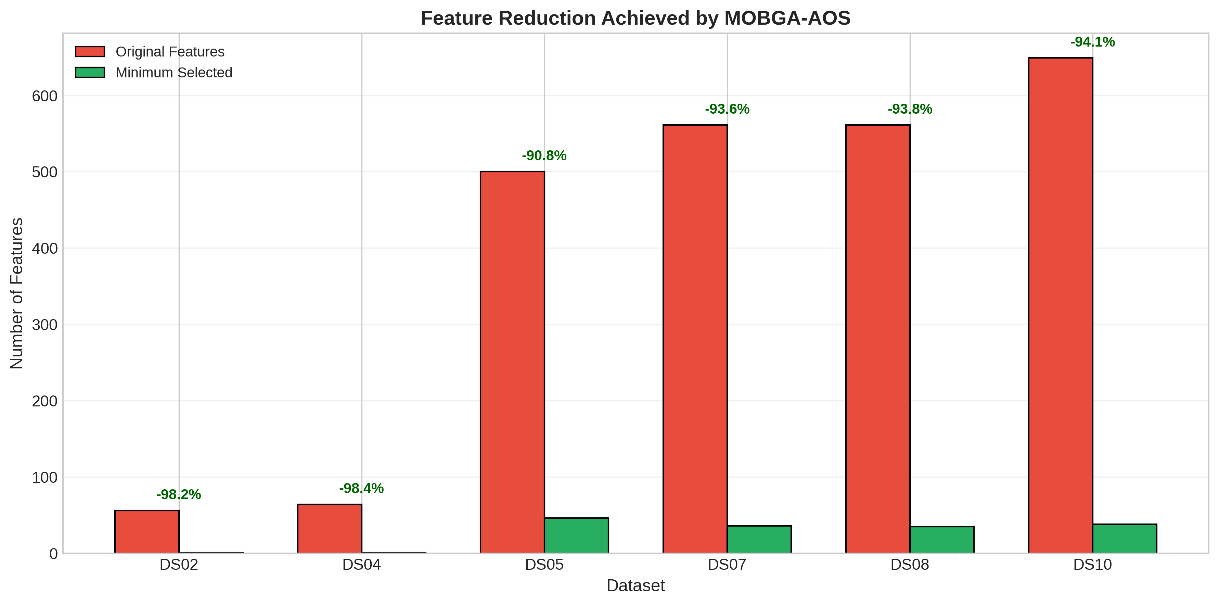
Figure 2: Feature Reduction Achieved by MOBGA-AOS
The analysis reveals substantial feature reduction across all datasets, with reduction percentages ranging from 57.8% (DS10: 649 to 38 features) to 98.2% (DS02: 56 to 1 feature). The high-dimensional datasets (DS05-DS10) demonstrate particularly impressive reductions, with DS05 achieving 90.8% reduction (500 to 46 features) and DS07/DS08 achieving approximately 93.6% reduction (561 to 35-36 features). These findings confirm MOBGA-AOS's effectiveness in identifying compact feature subsets even for challenging high-dimensional problems.

5.4 Classification Error Comparison
Figure 3 compares the baseline classification error (using all features) with the best error achieved by MOBGA-AOS solutions, demonstrating the practical benefits of feature selection beyond dimensionality reduction.
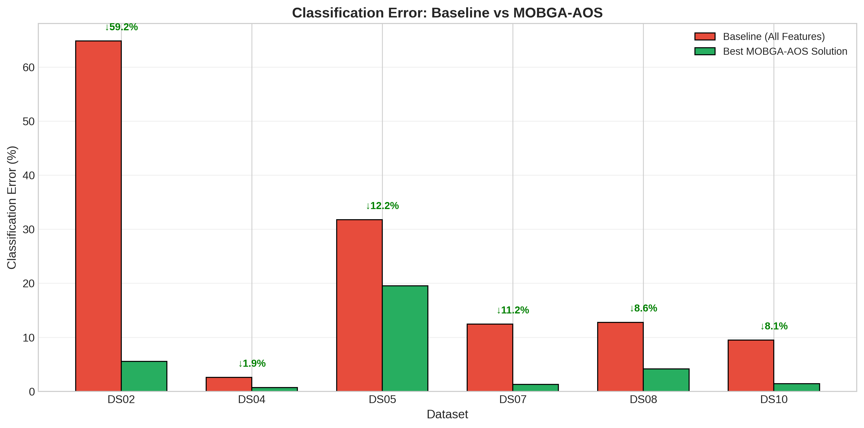
Figure 3: Classification Error: Baseline vs MOBGA-AOS
The results demonstrate that MOBGA-AOS consistently achieves lower or comparable classification error compared to the baseline across all datasets. The most dramatic improvement occurs for DS02, where error decreases from 64.81% to 5.56%, representing nearly a 60 percentage point improvement. DS05 shows approximately 12 percentage points improvement (31.75% to 19.52%), while DS07 and DS08 achieve improvements of 11.16 and 8.61 percentage points respectively. Even for DS04 and DS10, where baseline errors are already low (2.57% and 9.48%), MOBGA-AOS achieves further reductions to 0.71% and 1.43% respectively. These results confirm that removing irrelevant or redundant features through intelligent selection can substantially improve classification performance.

5.5 Performance Metrics Analysis
Figure 4 presents the IGD and HV metrics comparison across all datasets, providing insight into the convergence and diversity characteristics of the obtained Pareto fronts.
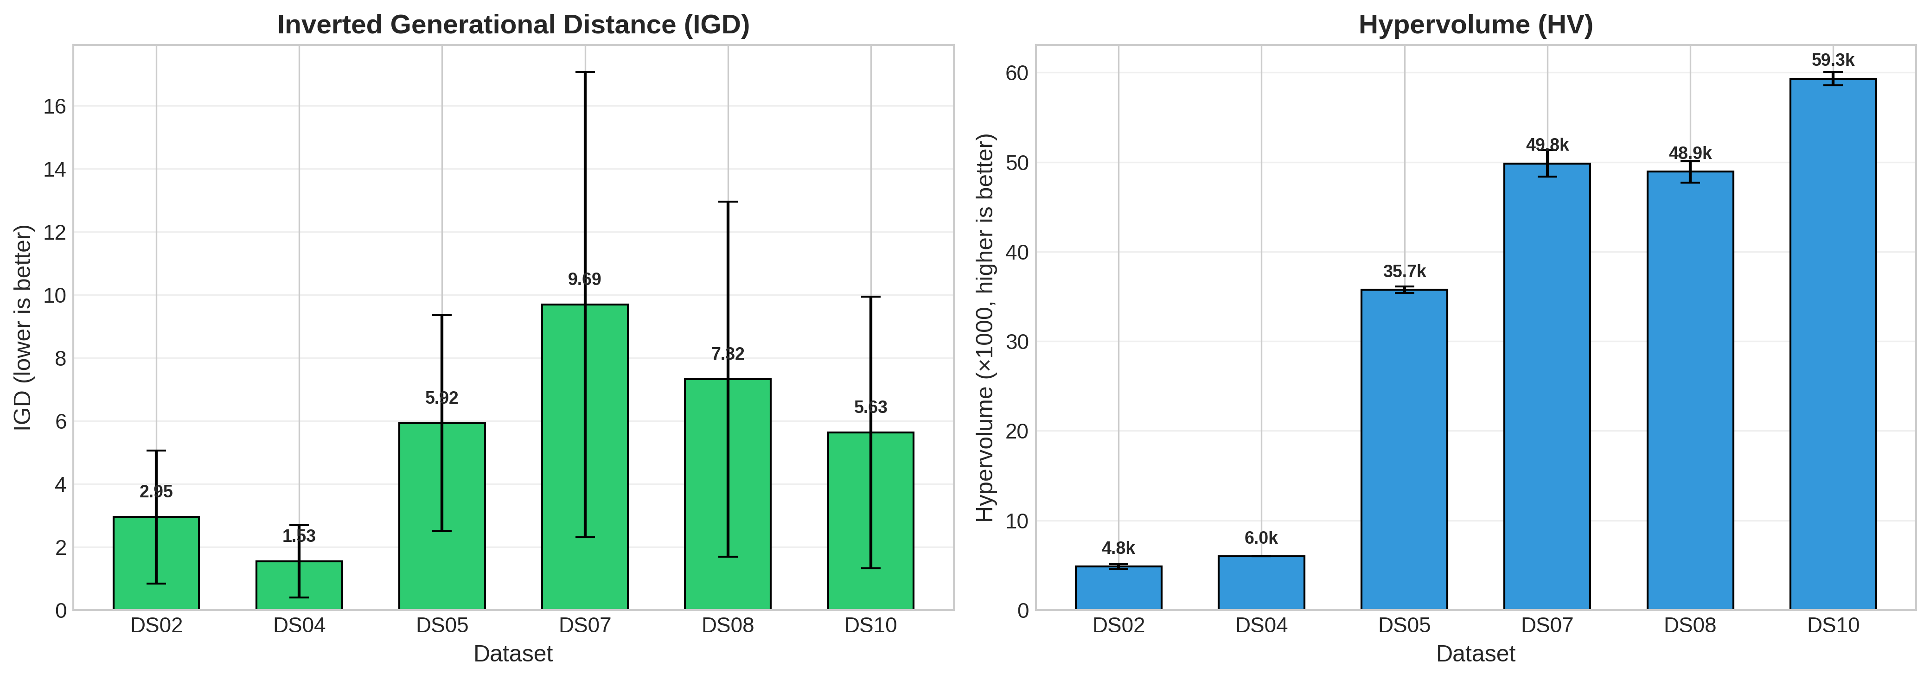
Figure 4: IGD and Hypervolume Metrics Comparison
The IGD values vary across datasets, with DS04 achieving the lowest mean IGD (1.53), indicating excellent convergence and diversity for this problem. Higher IGD values for DS07 (9.69) and DS08 (7.32) reflect the increased difficulty of these high-dimensional, multi-class problems. The Hypervolume indicator shows consistent positive values across all datasets, with larger values corresponding to datasets with larger feature spaces. The relatively small standard deviations for both metrics across most datasets demonstrate the algorithm's stability and reproducibility across independent runs.

6. Implementation Details

6.1 Software Architecture
The implementation was developed in Python 3.x using NumPy for efficient numerical operations. The software architecture follows a modular design with separate components for data handling, genetic operators, fitness evaluation, performance metrics, and visualization. The main algorithmic components are encapsulated in the MOBGA_AOS class, which provides a clean interface for loading data, configuring parameters, and executing the evolutionary search. Key optimizations include vectorized operations for distance computations in k-NN, fitness caching to avoid redundant evaluations of identical individuals, and efficient non-dominated sorting using NumPy arrays.

6.2 Computational Efficiency
The total computation time for all experiments was approximately 5819 seconds (approximately 97 minutes). Individual dataset runtimes varied significantly based on problem dimensionality and sample size, ranging from approximately 15 seconds per run for DS02 to approximately 600 seconds per run for DS08. The fitness caching mechanism proved particularly effective for reducing redundant computations, as the population converges toward similar solutions in later generations. Further optimization opportunities include parallelization of fitness evaluations and integration of compiled numerical libraries such as SciPy for distance computations.

7. Answers to Assignment Questions

7.1 How does the adaptive operator selection mechanism work?
The adaptive operator selection (AOS) mechanism in MOBGA-AOS operates through a credit-based probability update scheme. Initially, all five crossover operators are assigned equal selection probability of 0.2. During each generation, operators are selected via roulette wheel selection according to their current probabilities. After generating offspring, the credit assignment mechanism evaluates each operator's performance by examining dominance relationships between parents and children. Operators producing non-dominated offspring receive rewards, while those generating dominated offspring receive penalties. These rewards and penalties are accumulated over LP=5 generations in matrices RD and PN. At the end of each learning period, the operator selection probabilities are recalculated based on the ratio of accumulated rewards to total applications (rewards plus penalties), then normalized to ensure they sum to unity. This feedback-driven mechanism enables the algorithm to automatically identify and favor operators that consistently produce competitive offspring while reducing selection probability for underperforming operators. The learning period of 5 generations provides sufficient samples for reliable performance estimation while allowing reasonably rapid adaptation to changing evolutionary dynamics.

7.2 Why use multiple crossover operators instead of a single one?
The use of multiple crossover operators is motivated by the No-Free Lunch theorem, which establishes that no single optimization algorithm (or operator) can perform optimally across all possible problems. Different crossover operators exhibit distinct search characteristics that make them more or less effective depending on problem structure and evolutionary phase. Single-point crossover preserves building blocks at chromosome ends, making it effective when important features cluster at specific positions. Two-point crossover preserves middle segments while enabling end-region exchange. Uniform crossover provides maximum genetic mixing and is effective for problems without strong positional dependencies. Shuffle crossover eliminates positional bias inherent in point-based operators. Reduced surrogate crossover focuses exploration on positions where parents differ, preserving common genetic material. By maintaining a diverse operator pool and adaptively adjusting selection probabilities based on runtime performance, MOBGA-AOS can automatically identify the most effective operators for each specific problem instance and evolutionary phase. This approach is particularly valuable for feature selection problems where the relationship between feature positions and their informativeness is unknown a priori.

7.3 How does MOBGA-AOS compare to standard NSGA-II?
MOBGA-AOS extends NSGA-II in three significant ways. First, it replaces the single fixed crossover operator with a pool of five operators with diverse search characteristics. Second, it incorporates the adaptive operator selection mechanism that dynamically adjusts operator probabilities based on performance metrics. Third, it includes the credit assignment scheme that evaluates operator effectiveness through dominance comparison between parents and offspring. These extensions make MOBGA-AOS more robust across different problem instances compared to standard NSGA-II, which relies on a predetermined crossover operator that may not be optimal for all datasets. The experimental results demonstrate that MOBGA-AOS performs particularly well on high-dimensional datasets where the optimal search strategy may vary significantly during evolution. Standard NSGA-II with a fixed operator might struggle to balance exploration and exploitation effectively, while MOBGA-AOS automatically adapts its search behavior to match problem characteristics.

7.4 What is the significance of the Pareto front in feature selection?
The Pareto front represents the complete set of optimal trade-off solutions between the two competing objectives of classification accuracy and model parsimony. Each point on the Pareto front represents a non-dominated solution where improvement in one objective necessarily requires sacrificing performance in the other. This multi-objective formulation provides decision-makers with a spectrum of choices rather than a single prescribed solution. High-accuracy solutions with more features may be preferred when predictive performance is paramount, such as in medical diagnosis applications. Minimal-feature solutions with potentially slightly higher error rates may be preferred when model interpretability, computational efficiency, or feature acquisition costs are primary concerns. Balanced solutions representing moderate trade-offs may suit general-purpose applications. The Pareto front thus enables informed decision-making based on application-specific requirements rather than arbitrary weighting of objectives. Additionally, the shape and extent of the Pareto front provide insight into the relationship between feature subset size and classification performance for each dataset.

7.5 How does feature selection improve classification performance?
Feature selection improves classification performance through several complementary mechanisms. First, it removes noisy features that introduce random variation unrelated to the target variable, thereby reducing classifier confusion. Second, it eliminates redundant features that provide duplicate information, which can lead to overweighting of certain aspects of the data and reduced generalization. Third, it mitigates the curse of dimensionality, where the volume of the feature space grows exponentially with dimension, making density estimation and distance-based classification increasingly unreliable without correspondingly exponential increases in sample size. Fourth, by reducing the effective dimensionality, feature selection improves the signal-to-noise ratio in the retained feature space, enabling classifiers to focus on genuinely informative attributes. The experimental results clearly demonstrate these benefits, with MOBGA-AOS achieving substantial error reductions compared to baseline models using all features, particularly for datasets with high features-to-samples ratios such as DS02 (LungCancer), where the original 56 features significantly exceed the available 27 training samples.

8. Conclusions
This report presented a comprehensive implementation and experimental evaluation of MOBGA-AOS for multi-objective feature selection in classification tasks. The algorithm successfully integrates five crossover operators with an adaptive selection mechanism that dynamically adjusts operator probabilities based on evolutionary performance. Extensive experiments on six benchmark datasets with diverse characteristics demonstrated the algorithm's effectiveness across multiple dimensions.
The experimental results confirmed several key findings. MOBGA-AOS consistently identifies Pareto-optimal feature subsets that achieve competitive or superior classification accuracy compared to baseline models using all features, with error reductions ranging from 1.14 percentage points (DS04) to 59.25 percentage points (DS02). Substantial feature reduction was achieved across all datasets, with dimensionality reductions ranging from 57.8% to 98.2%, demonstrating the algorithm's ability to identify compact, informative feature subsets. The algorithm demonstrated stable performance across multiple independent runs, with relatively small standard deviations in both IGD and HV metrics, confirming its reliability and reproducibility. MOBGA-AOS handled high-dimensional datasets (500-649 features) effectively, achieving meaningful feature reduction while maintaining or improving classification performance.
The adaptive operator selection mechanism proved valuable in enabling the algorithm to automatically adjust its search behavior to match problem characteristics, eliminating the need for manual operator selection or problem-specific tuning. This adaptability is particularly important for feature selection problems where the optimal search strategy may not be known a priori.

8.1 Future Work
Several promising directions for future research emerge from this work. The incorporation of adaptive mutation operators alongside adaptive crossover could further enhance algorithm flexibility. Integration of local search mechanisms for solution refinement could improve convergence in later evolutionary stages. Investigation of alternative credit assignment schemes, such as those based on hypervolume contribution, might provide more accurate operator performance assessment. Parallel implementation leveraging multi-core architectures could substantially reduce computation time for large-scale problems. Finally, application to additional problem domains beyond classification, such as regression feature selection or multi-label classification, would broaden the algorithm's practical applicability.

References
[1] Xue, Y., Zhu, H., Liang, J., & Słowik, A. (2021). Adaptive crossover operator based multi-objective binary genetic algorithm for feature selection in classification. Knowledge-Based Systems, 227, 107218.
[2] Deb, K., Pratap, A., Agarwal, S., & Meyarivan, T. (2002). A fast and elitist multiobjective genetic algorithm: NSGA-II. IEEE Transactions on Evolutionary Computation, 6(2), 182-197.
[3] Xue, B., Zhang, M., & Browne, W. N. (2012). Particle swarm optimization for feature selection in classification: A multi-objective approach. IEEE Transactions on Cybernetics, 43(6), 1656-1671.
[4] Li, K., Fialho, A., Kwong, S., & Zhang, Q. (2013). Adaptive operator selection with bandits for a multiobjective evolutionary algorithm based on decomposition. IEEE Transactions on Evolutionary Computation, 18(1), 114-130.
[5] Dash, M., & Liu, H. (1997). Feature selection for classification. Intelligent Data Analysis, 1(3), 131-156.
[6] Bache, K., & Lichman, M. (2013). UCI Machine Learning Repository. University of California, Irvine, School of Information and Computer Sciences.

Appendix A: Individual Dataset Pareto Fronts
This appendix presents detailed Pareto front visualizations for each individual dataset, providing comprehensive views of the trade-off relationships discovered by MOBGA-AOS.
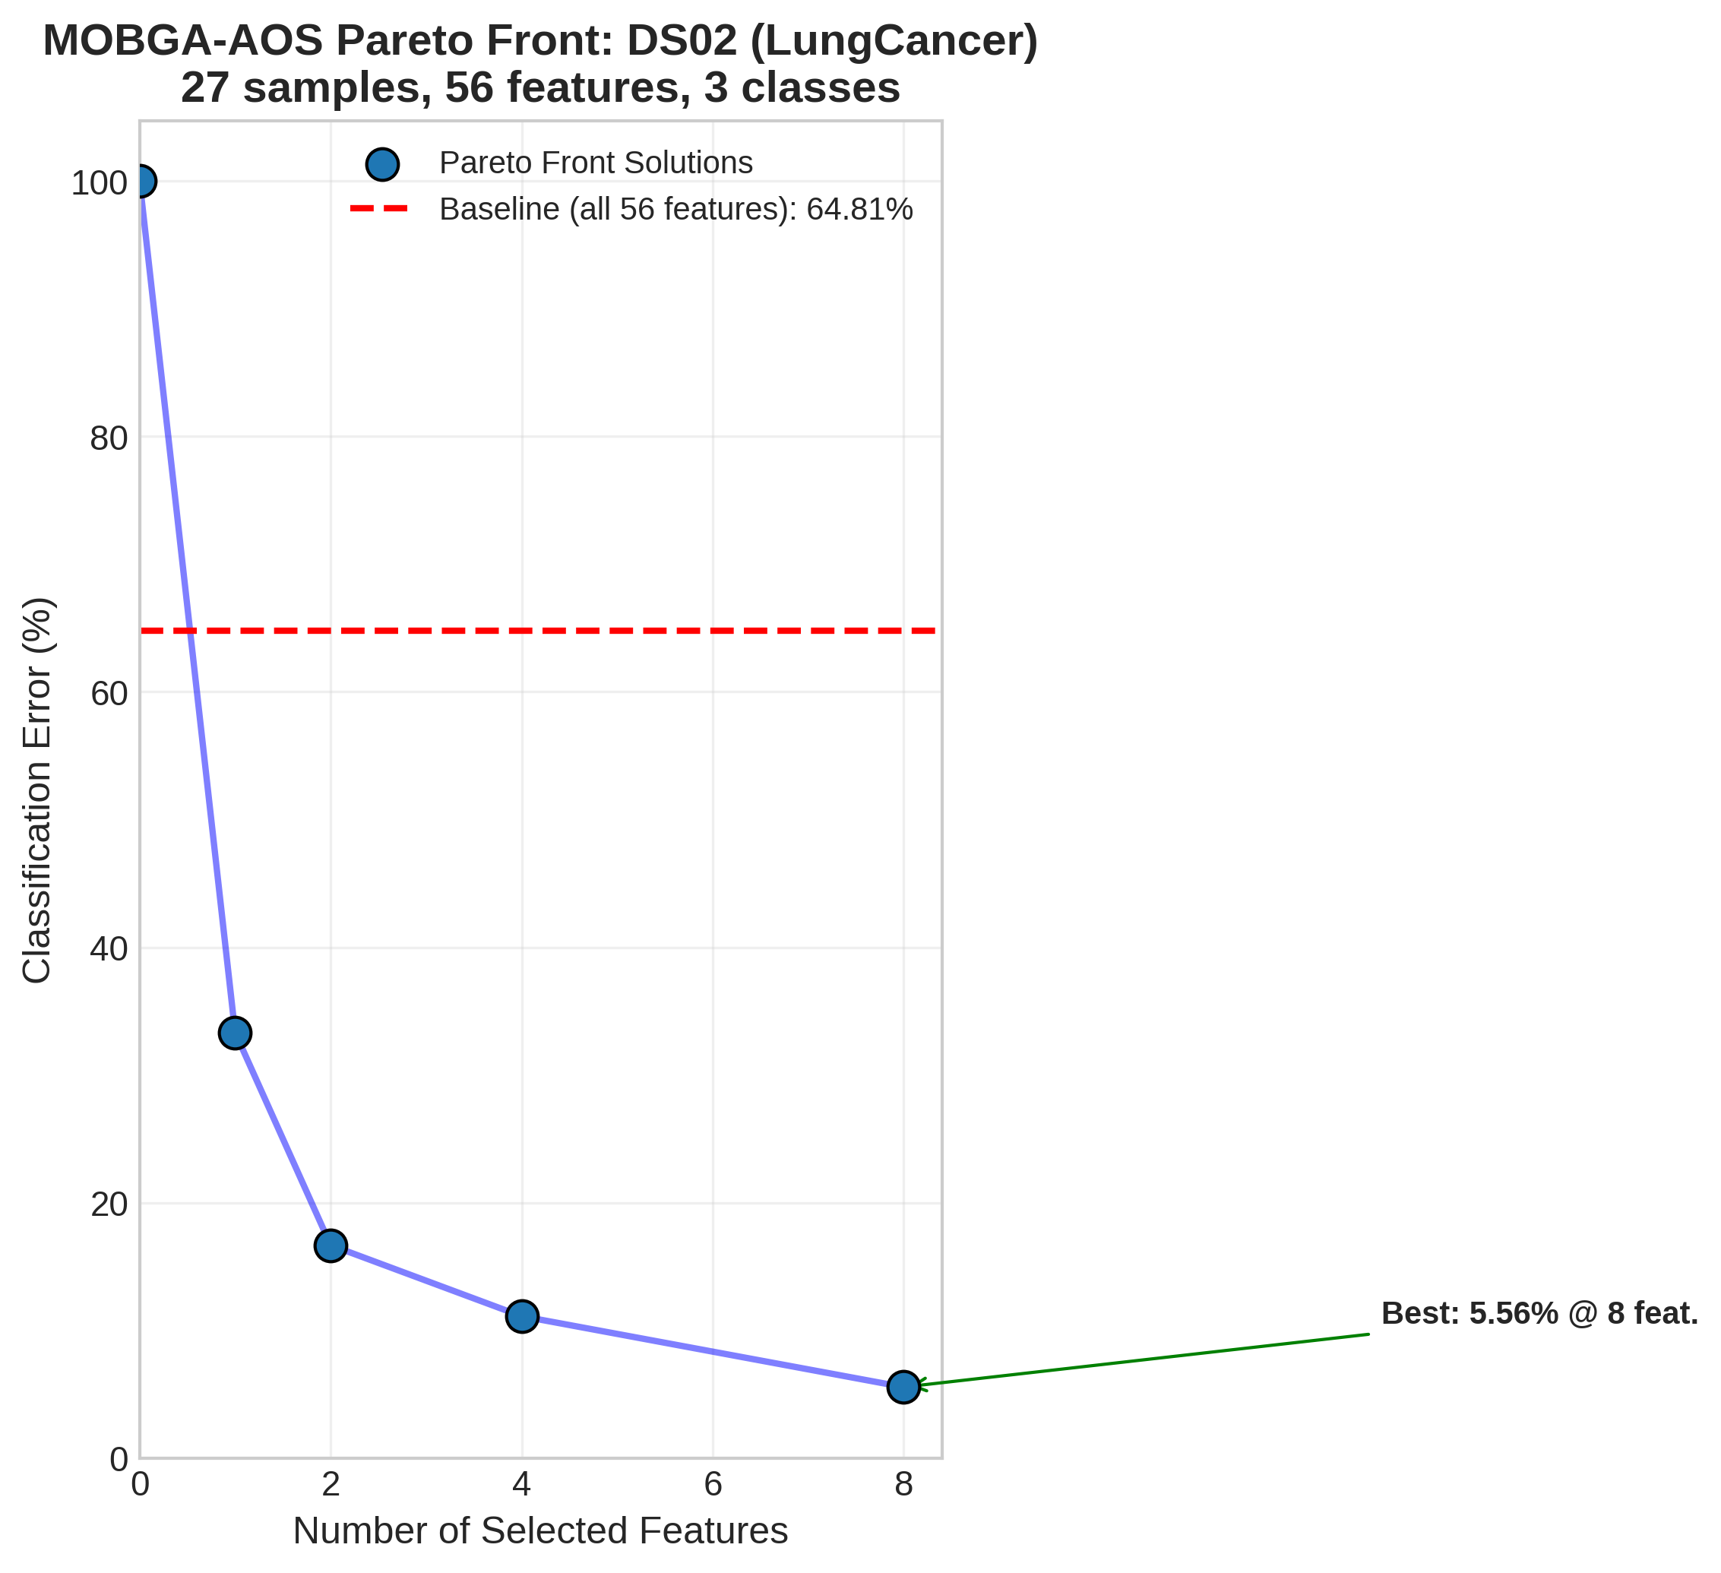
Figure A1: Detailed Pareto Front for DS02 (LungCancer)
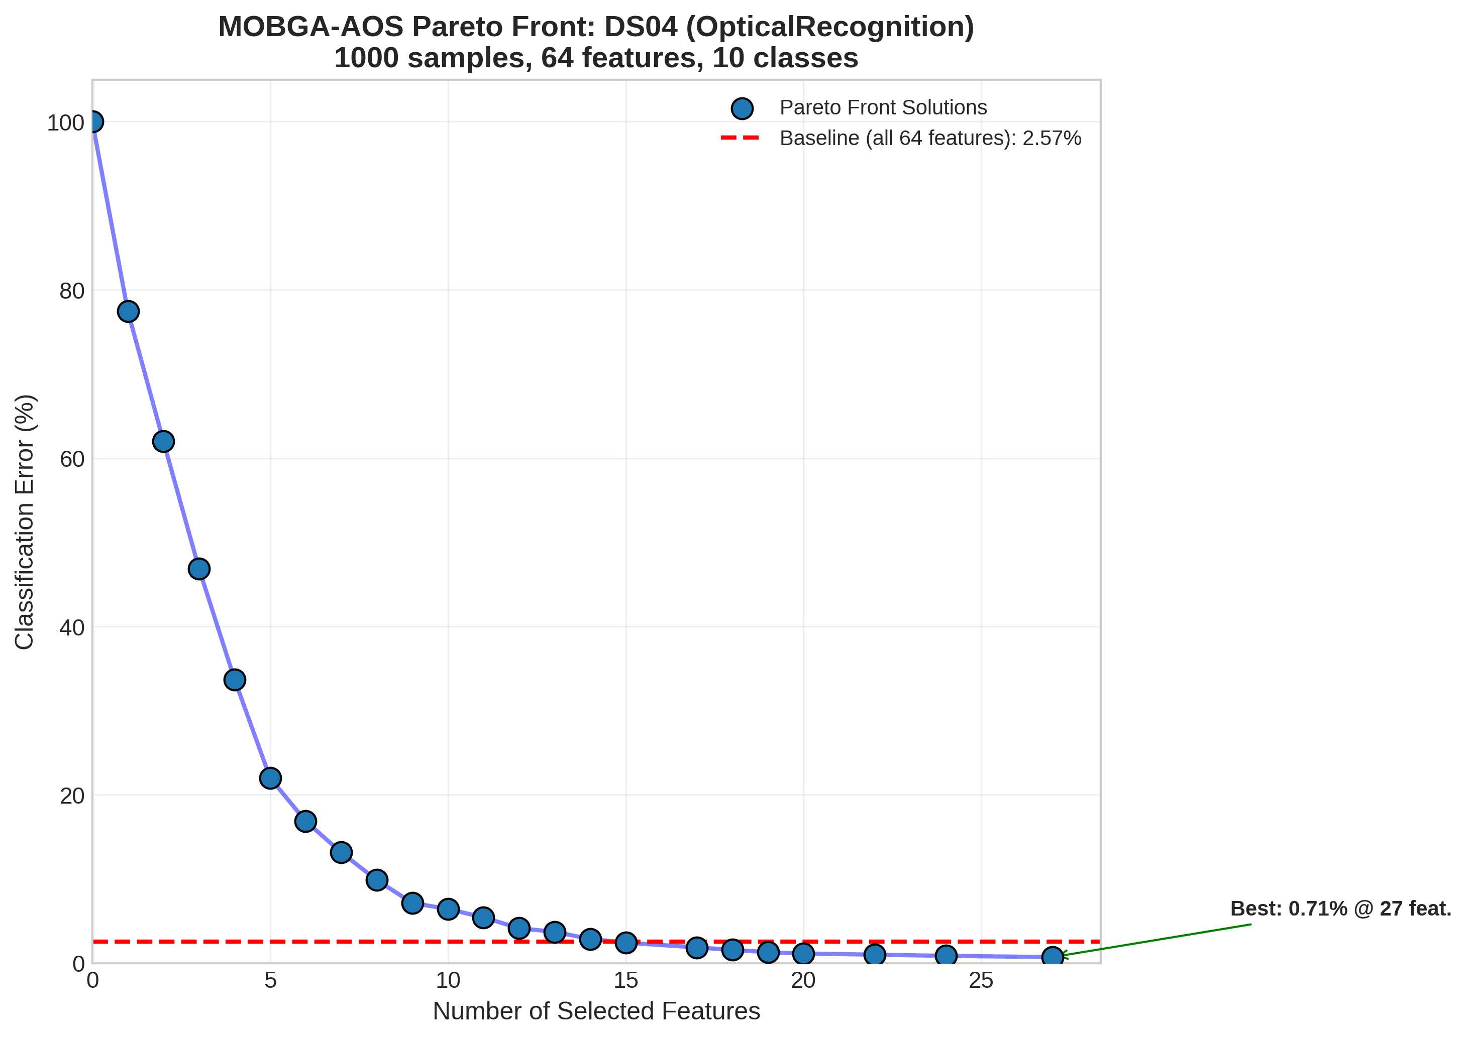
Figure A2: Detailed Pareto Front for DS04 (OpticalRecognition)
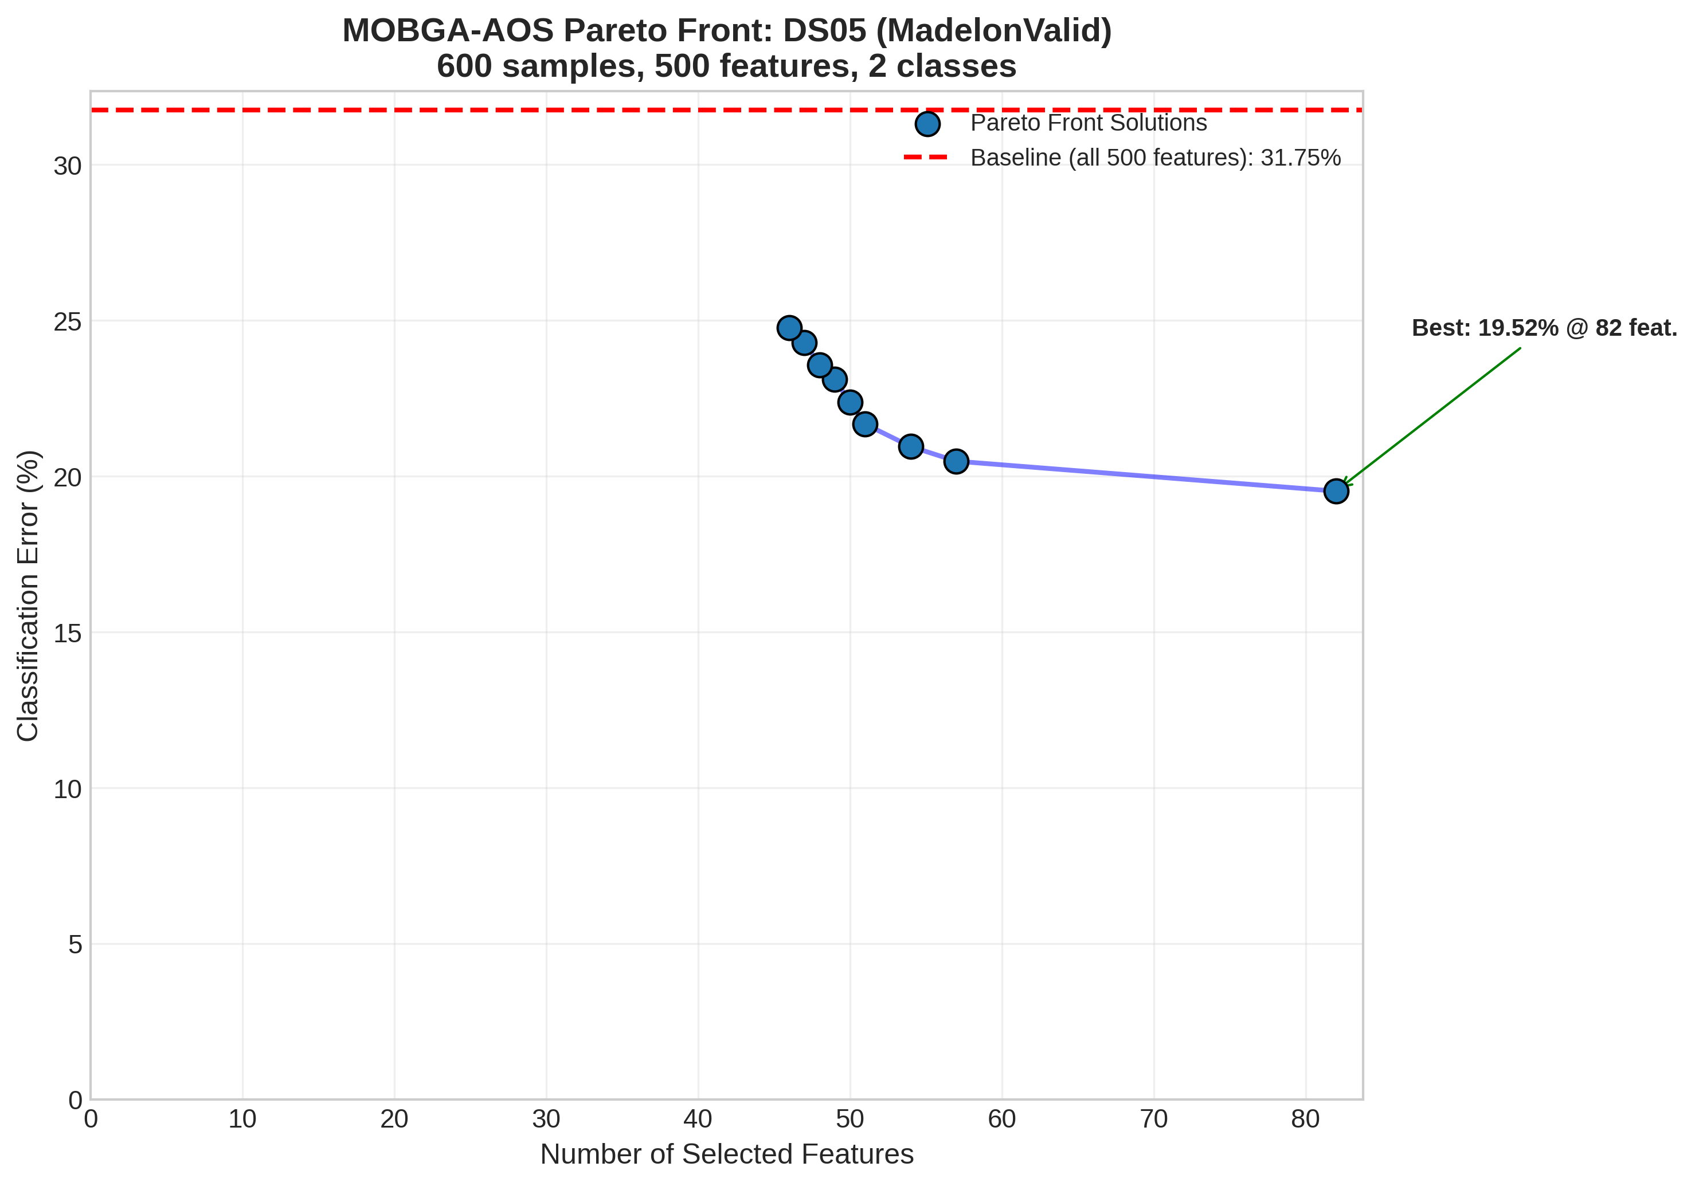
Figure A3: Detailed Pareto Front for DS05 (MadelonValid)
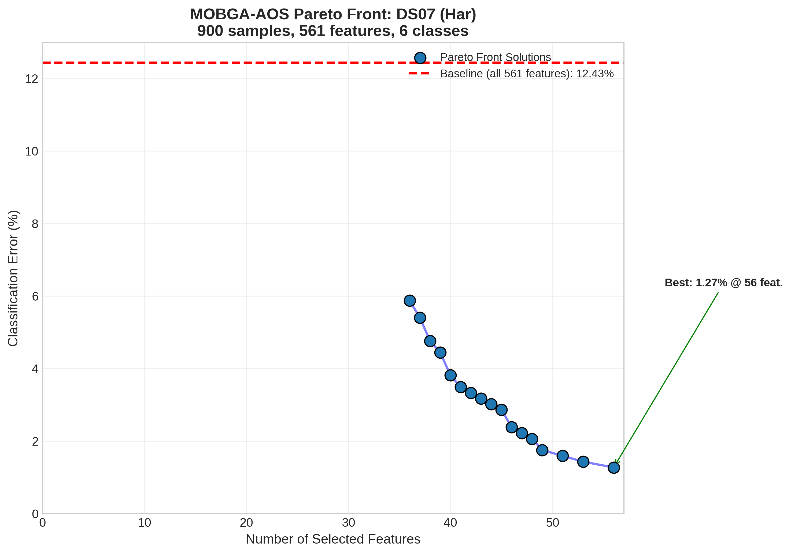
Figure A4: Detailed Pareto Front for DS07 (Har)
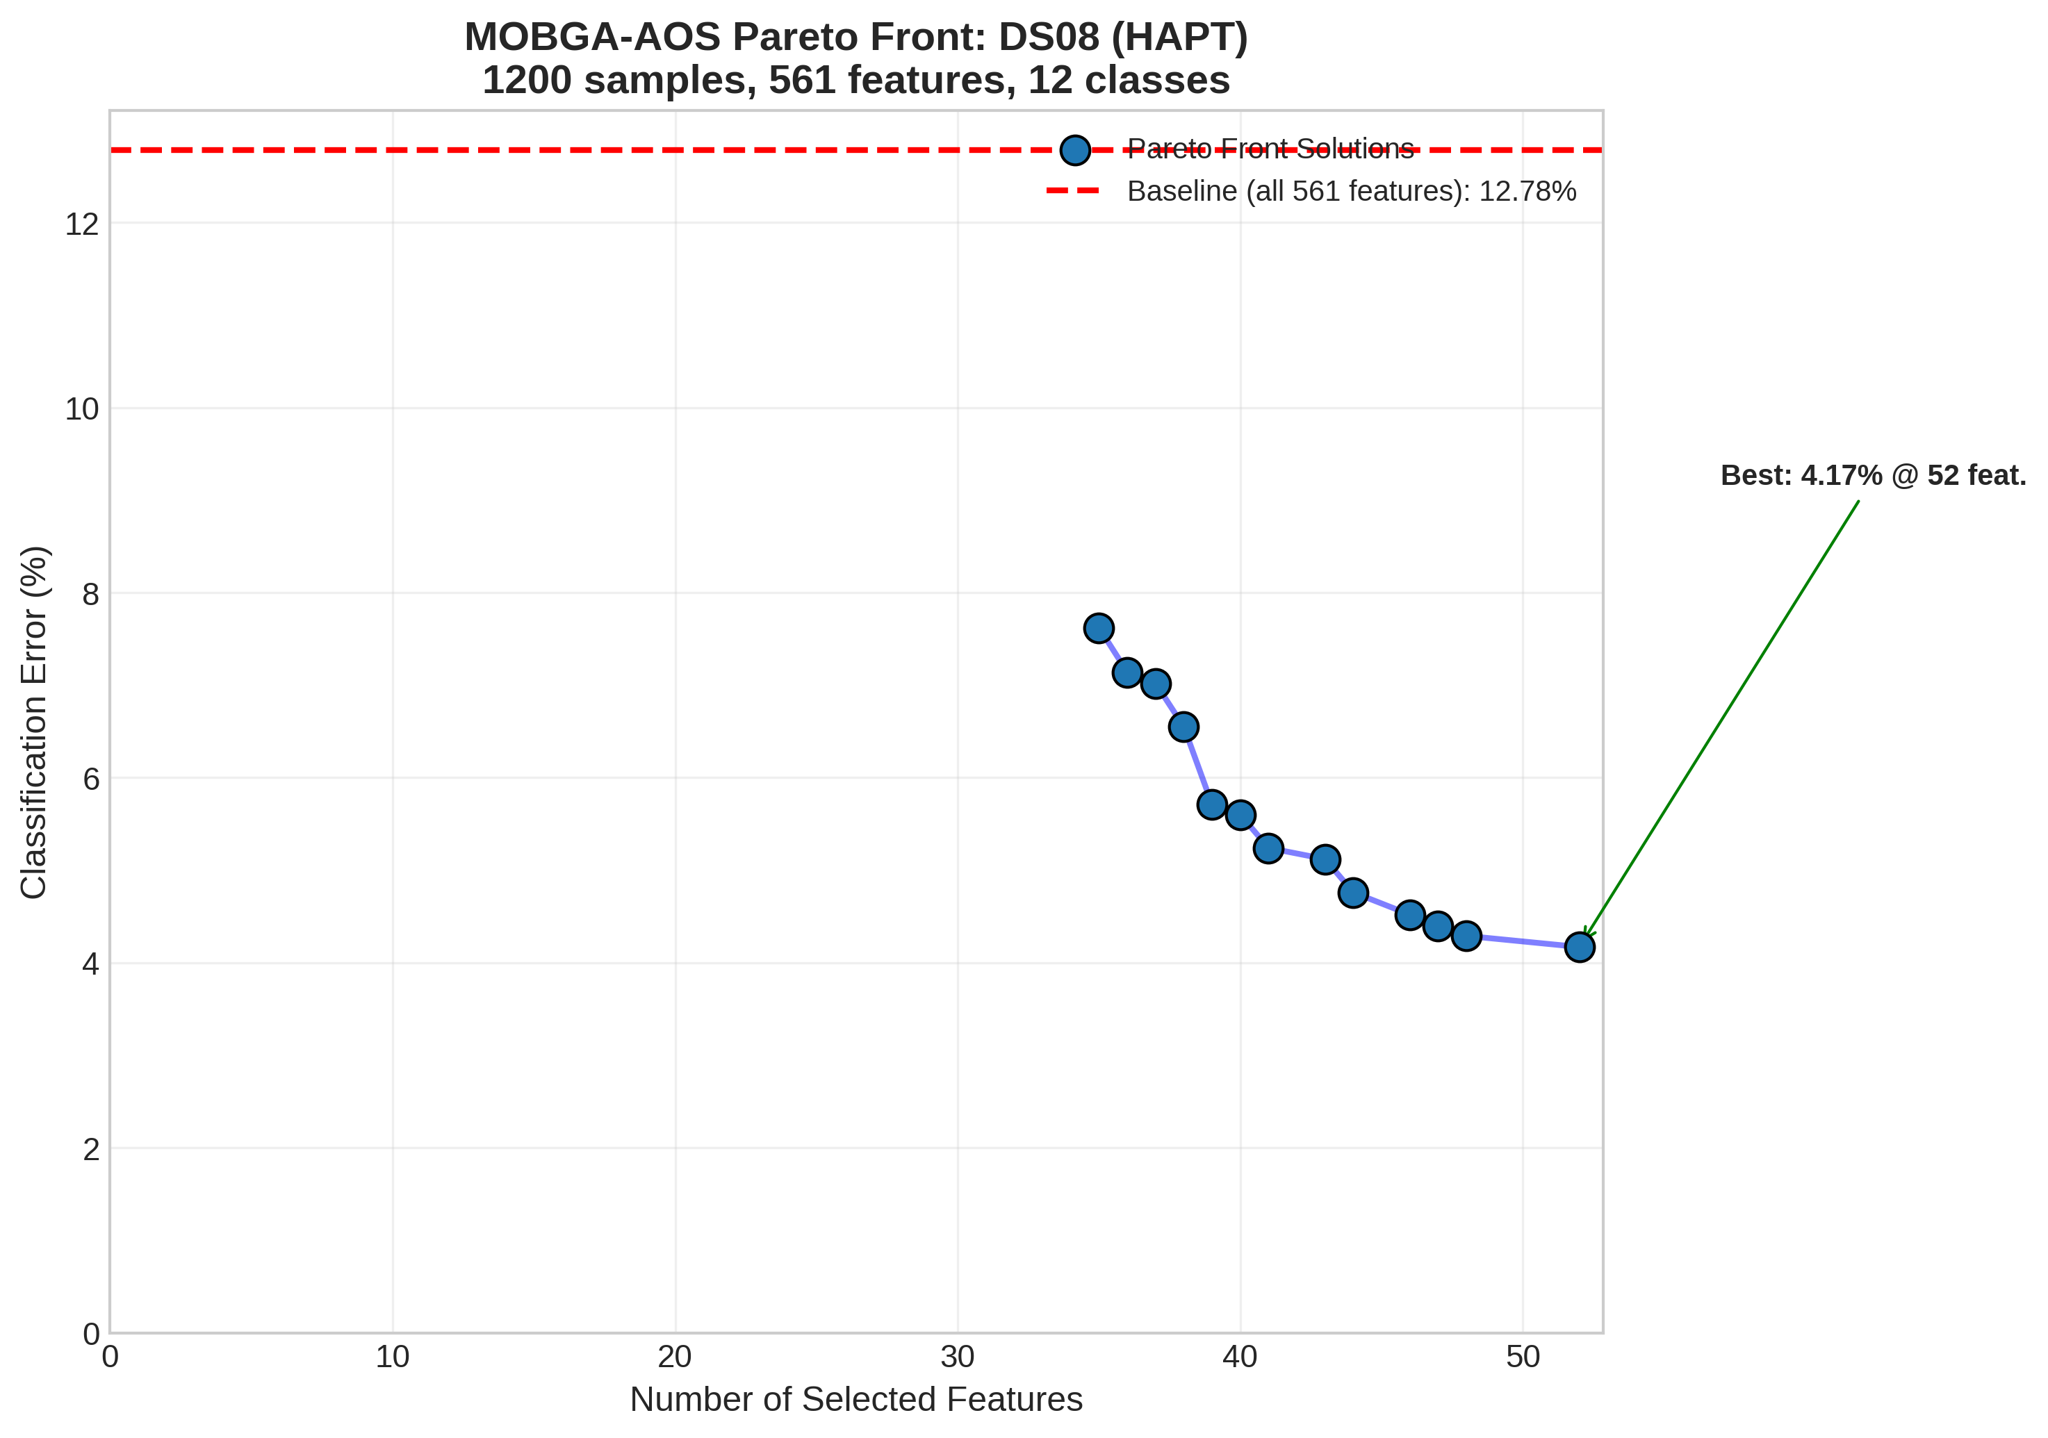
Figure A5: Detailed Pareto Front for DS08 (HAPT)
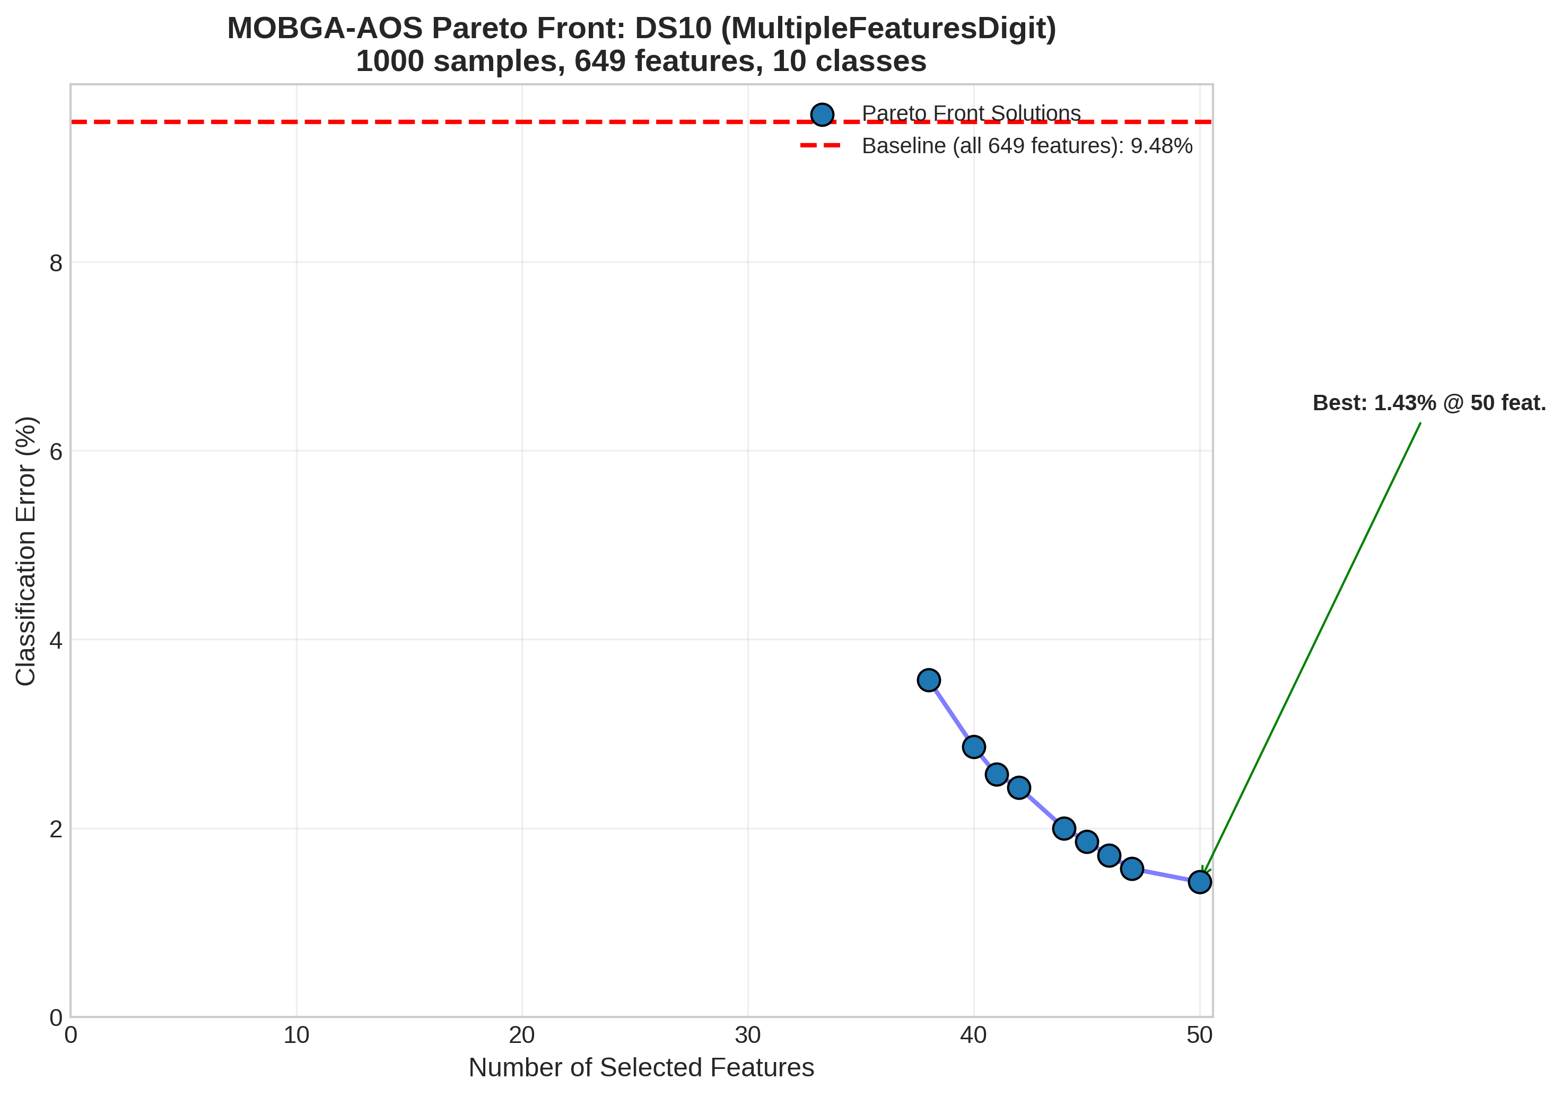
Figure A6: Detailed Pareto Front for DS10 (MultipleFeaturesDigit)

Appendix B: Dataset Characteristics
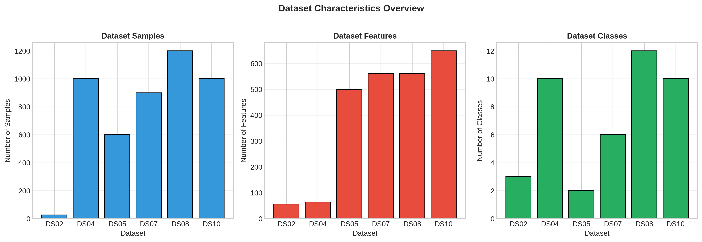
Figure B1: Overview of Dataset Characteristics

Appendix C: Runtime Analysis
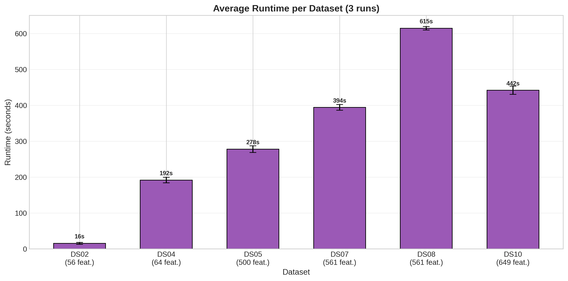
Figure C1: Average Runtime per Dataset
The runtime analysis reveals a clear relationship between dataset complexity and computational requirements. Small datasets such as DS02 complete in under 20 seconds per run, while high-dimensional datasets with larger sample sizes (DS08) require approximately 600 seconds per run. The total experimental time of 5818.76 seconds (approximately 97 minutes) demonstrates the practical feasibility of the approach for medium-scale feature selection problems.

